The Trans-Theoretical Model of Health Behavior Change (TMHBC) has successfully been used to change addictive behaviors such as smoking (Prochaska, 1997). This model describes 6 stages of readiness for behavior change, defined and illustrated in the diagram below:

1. Precontemplation: not even thinking about changing (“I’m not going to quit smoking”),
2. Contemplation: see a problem; think about acting (“I want to quit but don’t know how”),
3. Preparation: preparing to act; (I’m learning what to do and planning when to quit);
4. Action: make a change and use available tools (“I’ve quit and am using the patch”);
5. Maintenance: sustaining the gains (“I’m avoiding smoking situations such as bars”); and
6. Relapse: return to original behavior.
Pre-contemplation Contemplation Preparation Action
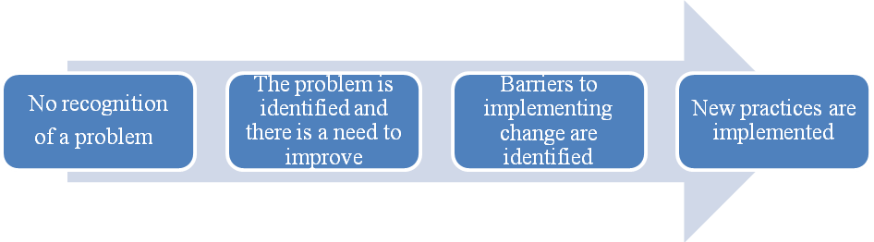The TMHBC has also been applied to healthcare organizations and shown to explain the acceptance of and readiness to make organizational and practice changes (Prochaska, 2001). Historically, many healthcare quality improvement initiatives have tended to target primarily those providers already at either the contemplation or preparation phase and to assume that all that needs to be done is to offer the provider or practitioner education or information about specific interventions or care practices that should be implemented. While this may be the case for those organizations already poised to act, the approach fails to address those at earlier stages on the readiness continuum, who will not readily embrace the desired change until they recognize and decide they need to act on a problem. It also fails to account for the intermediate step of providing support and resources to organizations not only on specific practice changes, but also on the methods most likely to be successful in implementing those changes and the broader organizational factors essential to supporting and sustaining success.

